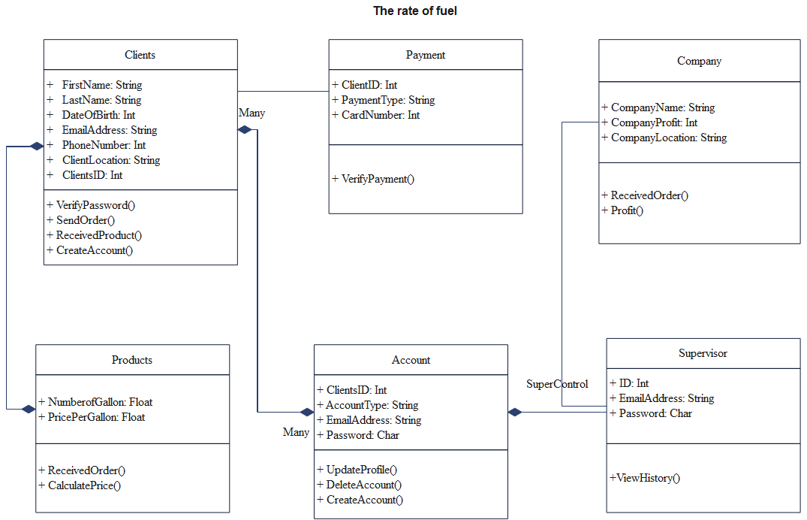

In our website design, we will make a page for customer creating their account, a page for customer completing their profile, a page for paying order, a page for supervisor check income as well as orders of company, a page for saving data of fuel history.

The design and method are mentioned in our question one and two.